**PIZZA SALES SQL QUERIES**

**A.KPI’S**

**1.Total Revenue:**

select sum(total_price) As Total_Revenue from pizza_sales;

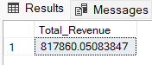

**2.Average Order Value:**

select sum(total_price)/COUNT(DISTINCT order_id) AS Avg_Order_Value from pizza_sales

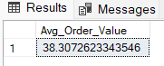

**3.Total Pizza sold:**

select sum(quantity)as Total_pizza_sold from pizza_sales

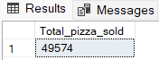

**4.Total Order:**

select count(DISTINCT order_id) as Total_order from pizza_sales

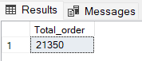

**5.Average Pizza per order:**

SELECT CAST(CAST(SUM(quantity) AS DECIMAL(10,2))

/ CAST(COUNT(DISTINCT order_id) AS DECIMAL(10,2)) AS DECIMAL(10,2)) as avg_pizza_order FROM pizza_sales

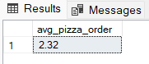

**6.Daily Total order:**

SELECT DATENAME(DW,order_date) AS order_day,COUNT(DISTINCT order_id) AS Total_order from pizza_sales

GROUP BY DATENAME(DW,order_date)

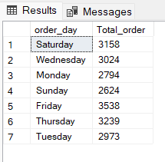

**7.Monthly Total Order:**

s AS month_name,COUNT(DISTINCT order_id) AS Total_order from pizza_sales

GROUP BY DATENAME(MONTH,order_date) ORDER BY Total_order DESC

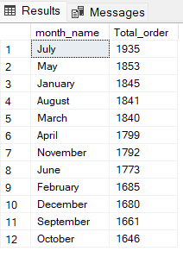

8.pizza category:

SELECT pizza_category,sum (total_price) as total_sale,sum(total_price)*100/(SELECT sum(total_price) from pizza_sales WHERE MONTH(order_date)=1) AS PTC from pizza_sales

WHERE MONTH(order_date)=1

GROUP BY pizza_category

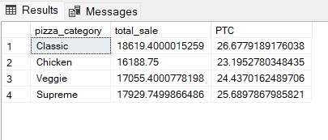

**9.pizza size:**

SELECT pizza_size,sum (total_price) as total_sale,CAST(sum(total_price)*100/(SELECT sum(total_price) from pizza_sales) AS DECIMAL(10,2)) AS PTS from pizza_sales

GROUP BY pizza_size

ORDER BY PTS DESC

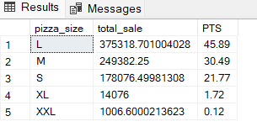

**10.top 5 most revenue:**

SELECT Top 5 pizza_name,sum(total_price) AS total_revenue from pizza_sales

GROUP BY pizza_name

ORDER BY total_revenue DESC

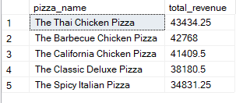

**11.bottom 5 revenue:**

SELECT Top 5 pizza_name,sum(total_price) AS total_revenue from pizza_sales

GROUP BY pizza_name

ORDER BY total_revenue ASC

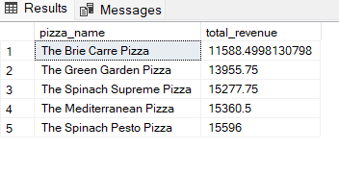

**12.Top 5 by quantity :**

SELECT Top 5 pizza_name,sum(quantity) AS total_quantity from pizza_sales

GROUP BY pizza_name

ORDER BY total_quantity DESC

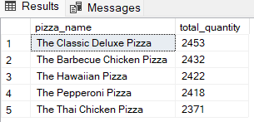

**13.Top 5 by order:**

SELECT Top 5 pizza_name,COUNT(DISTINCT order_id)AS total_order from pizza_sales

GROUP BY pizza_name

ORDER BY total_order DESC

